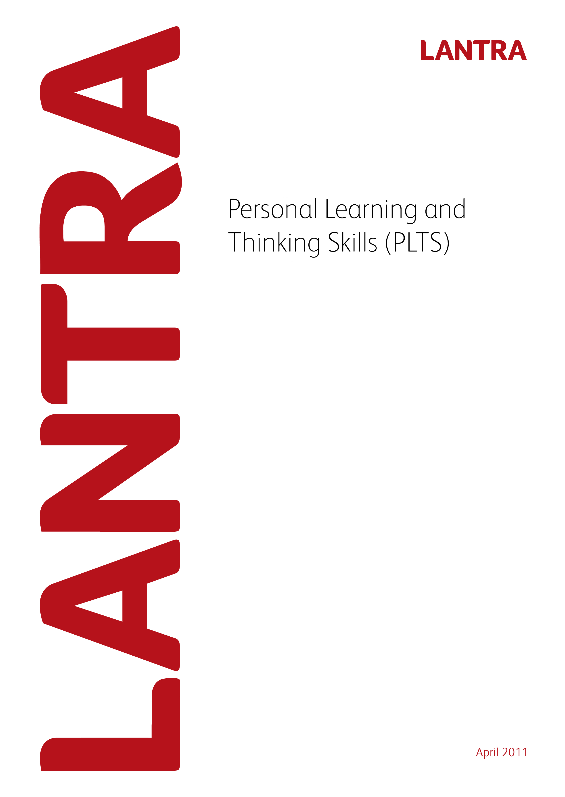

Record of Achievement for
Environmental Conservation
Level 3
Record of Achievement for
Environmental Conservation
Level 3
February 2013

Personal Learning and Thinking Skills

Record of Achievement

Environmental Conservation Level 3

April 2011
This page has been intentionally left blank.

Record of Achievement
for
Personal Learning and Thinking Skills

Learner Name: _____________________________________________________

April 2011

Introduction

All apprenticeship frameworks must specify the outcomes which an apprentice is to achieve in the six Personal Learning and Thinking Skills (PLTS) listed below and how they are evidenced. Achievement of PLTS must be based on evidence that is subject to quality assurance. This Record of Achievement is based on quality assured evidence within the Level 3 Diploma in Work-based Environmental Conservation. The six PLTS and their outcomes include:

- Independent enquiry
- Creative thinking
- Reflective learning
- Team working
- Self management
- Effective participation

PLTS must be formally assessed. However; Lantra considers that assessment of units within the Work-based Diplomas provides relevant evidence for the achievement of PLTS. To this end, examples of where this evidence occurs and can be assessed, is provided within this document. Where there is an opportunity for a PLTS to be assessed, this appears as a blank (white) box. Assessors will need to list examples of evidence of how the PLTS have been achieved. Alternatively, assessor may devise their own sources of evidence and this needs to be specified, along with the unit within the Diploma where this alternative evidence occurred. Assessors will need to also sign and date at the end of each section.

Lantra does not require PLTS to be accredited. Although PLTS are referenced and mapped to QCF units within the Work-based Diplomas, assessors should be flexible in their interpretation to avoid discrimination against those with a learning difficulty. For example; care should be taken to ensure that interpretation of references to ‘speaking and listening’ are inclusive, as far as possible, of those with speech and hearing difficulties.

PLTS should be assessed alongside the learner’s assessment for the Work-based Diplomas and once achieved should be recorded on the following record sheets.

The sign off sheet at the end of the document should be completed by the learner and the assessor. The PLTS sign off sheet should be subject to the normal Internal Verifier sampling arrangements and so there is an opportunity for them to sign if appropriate. The sign off sheet should then be submitted to Lantra SSC when a claim is made for the Apprenticeship Certificate.

Independent enquirers | Creative thinkers | Reflective learners
- Identify questions to answer and problems to resolve  - Plan and carry out research, appreciating the consequences of decisions  - Explore issues, events or problems from different perspectives  - Analyse and evaluate information, judging its relevance and value  - Consider the influence of circumstances, beliefs and feelings on decision and events  - Support conclusions, using reasoned arguments and evidence | - Generate ideas and explore possibilities  - Ask questions to extend their thinking  - Connect their own and others’ ideas and experiences in inventive ways  - Question their own and others’ assumptions  - Try out alternatives or new solutions and follow ideas through  - Adapt ideas as circumstances change | - Assess themselves and others, identifying opportunities and achievements  - Set goals with success criteria for their development and review work  - Review progress, acting on the outcomes  - Invite feedback and deal positively with praise, setbacks and criticism  - Evaluate experiences and learning to inform future progress  - Communicate their learning in relevant ways for different audiences
Team workers | Self-managers | Effective participators
- Collaborate with others to work towards common goals  - Reach agreements, managing discussions to achieve results  - Adapt behaviour to suit different roles and situations, including leadership roles  - Show fairness and consideration to others  - Take responsibility, showing confidence in themselves and their contribution  - Provide constructive support and feedback to others | 1 seek out challenges or new responsibilities and show flexibility when priorities change  2 work towards goals, showing initiative, commitment and perseverance  3 organise time and resources, prioritising actions  4 anticipate, take and manage risks  5 deal with competing pressures, including personal and work-related demands  6 respond positively to change, seeking advice and support when needed  7 manage their emotions, and build and maintain relationships | - Discuss issues of concern, seeking resolution where needed  - Present a persuasive case for action  - Propose practical ways forward, breaking these down into manageable steps  - Identify improvements that would benefit others as well as themselves  - Try to influence others, negotiating the balancing diverse views to reach workable solutions  - Act as an advocate for views and beliefs that may differ from their own

Environmental Conservation Mandatory units |  | Independent enquirers | Creative thinkers | Reflective learners | Team workers | Self-managers | Effective participators
Level 3 – Environmental Conservation
Unit no. | Unit Title
D/502/1523 | Promote, monitor, and maintain health, safety and security of the workplace
Y/502/3285 | Implement environmental good practice at work
Y/502/3240 | Communicate with, and care, for the public and others
A/502/3232 | Plan, deliver and evaluate environmental projects

Reasons/examples of how learners may achieve the marked PLTS

Learners can develop independent enquirer skills as they plan and research, for example, environmental surveys and interpretation. They may analyse and evaluate information, judging its relevance and value, for example when agreeing policies for the development of land-based sites and evaluating environmental project work.

Learners may develop creative thinking skills when for example they develop interpretive entertainment and educational activities, as they question assumptions over the needs for collective action in the development of community environmental involvements. They could connect their own and other’s ideas and experiences as they work with children and/or involve others in, for example, recycling activities.

Learners can develop reflective learning skills as they for example assess others, identifying environmental improvement opportunities and achievements, communicate responsible use of the environment in responsible ways and review the progress of a relevant organisations characteristics, acting on outcomes.

Learners will often develop team working skills as their show fairness and consideration to others when working with the public, reach habitat maintenance agreements and collaborate with others towards common field survey and reporting.

Learners will often develop self-managing skills as they for example work with children towards goals showing initiative, anticipate and manage environmental pollution risks, and respond positively to changes in the protection of different land and vegetation sites.

Learners will often develop effective participation skills as they implement good environmental practice at work, identify improvements to habitat management objectives, influence others in the promotion of good environmental uses and propose practical ways forward in the management of vegetation.

Please indicate the method of assessment used within the relevant boxes.

I confirm that this candidate has achieved the PLTS for this framework.

Assessor name: __________________________

Assessor signature: __________________________

Date: __________________________

Environmental Conservation Mandatory units |  | Independent enquirers | Creative thinkers | Reflective learners | Team workers | Self-managers | Effective participators
Level 3 – Access and Recreation
Unit no. | Unit Title
D/502/1523 | Promote, monitor, and maintain health, safety and security of the workplace
Y/502/3285 | Implement environmental good practice at work
Y/502/3240 | Communicate with, and care, for the public and others
A/502/3232 | Plan, deliver and evaluate environmental projects

Reasons/examples of how learners may achieve the marked PLTS

Learners can develop independent enquirer skills as they plan and research for example access surveys and environmental interpretation. They will analyse and evaluate information, judging its relevance and value, for example when agreeing policies for the development of recreational sites and evaluating environmental recreation projects.

Learners can develop creative thinking skills when for example they explore interpretive entertainment and educational possibilities, as they question assumptions over the needs for collective action in the development of community recreational involvements. They could connect their own and other’s ideas and experiences as they work with children and/or involve others in community activities.

Learners can develop reflective learning skills as they for example assess others, identifying environmental improvement opportunities and achievements, communicate responsible use of the environment in relevant ways and review the progress of promoting an organisations characteristics, acting on outcomes.

Learners will often develop team working skills as their show fairness and consideration to others when working with the public, negotiate habitat maintenance agreements and collaborate with others towards common field survey and reporting.

Learners will often develop self-managing skills as they for example work with children towards goals showing initiative, anticipate and manage environmental pollution risks, and respond positively to changes in the implementation and/or maintenance of recreational sites.

Learners will often develop effective participation skills as they implement good environmental practice at work, identify improvements to habitat management objectives, influence others in the promotion of good environmental uses and propose practical ways forward in the management of vegetation.

Please indicate the method of assessment used within the relevant boxes.

I confirm that this candidate has achieved the PLTS for this framework.

Assessor name: __________________________

Assessor signature: __________________________

Date: __________________________

Environmental Conservation Mandatory units |  | Independent enquirers | Creative thinkers | Reflective learners | Team workers | Self-managers | Effective participators
Level 3 – Flood Risk Management
Unit no. | Unit Title
D/502/1523 | Promote, monitor, and maintain health, safety and security of the workplace

Reasons/examples of how learners may achieve the marked PLTS

Learners can develop independent enquiry skills as they for example explore flood risks and events, consider the influence of circumstances on emergency plans and arrangements and support flood survey conclusions using reasoned arguments and evidence.

Learners could develop creative thinking skills such as generating emergency arrangements, asking questions to extend their knowledge of emergency planning, and/or adapting risk assessments as circumstance change.

Learners could develop reflective learning skills such as reviewing health and safety and security implementation, communicating flood risks in relevant ways and inviting feedback and dealing with criticism positively when presenting interpretive media.

Learners are likely to develop team working skills as work on the installation of drainage systems, they are likely to adapt behaviour to suit flood management roles and situations and provide constructive support and feedback to others when planning for emergencies and risk management.

Learners are likely to self managing skills as they promote health and safety organising time and resources, build and maintain relationships with communities and dealing with competing pressures such as authority, community and emergency service needs.

Learners are likely to effective participating skills as they present a persuasive case for action in flood prevention, reach workable flood risk solutions and identify flood improvements that would benefit others as well as themselves.

Please indicate the method of assessment used within the relevant boxes.

I confirm that this candidate has achieved the PLTS for this framework.

Assessor name: __________________________

Assessor signature: __________________________

Date: __________________________

Record of Achievement
for
Personal Learning and Thinking Skills

Learner Name: __________________________________

Sign off sheet

I confirm that the learner has completed PLTS for the Level 3 Diploma in Work-based Environmental Conservation as part of an Apprenticeship Framework (please complete in BLOCK CAPITALS).

Learner Name: …………………………………. Signature: ………………

Date:………………

Assessor Name: …………………………………. Signature: ………………

Date: ………………

Internal Verifier Name: …………………………………. Signature: ………………

Date: ………………

Please return this sheet to Lantra SSC on completion of the Apprenticeship Framework.

This page has been left intentionally blank

