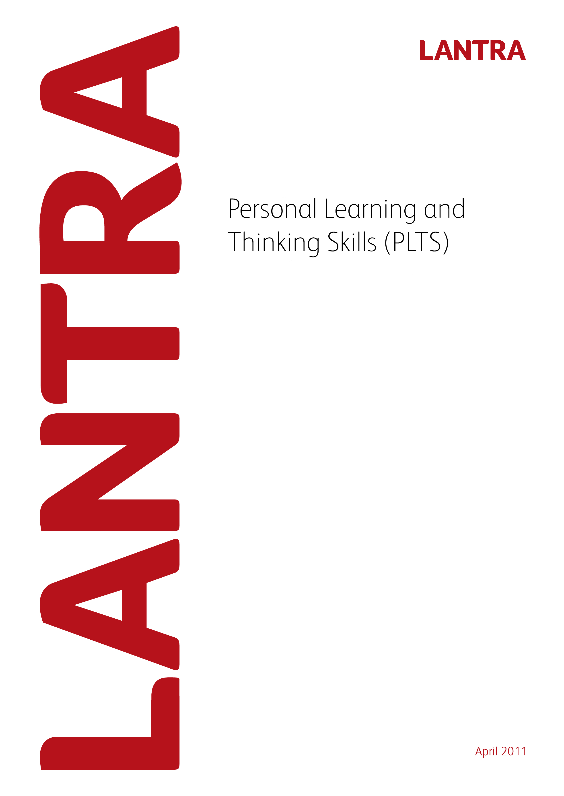
Record of Achievement for
Farriery
Level 3
Record of Achievement for
Farriery
Level 3
July 2011
This page has been intentionally left blank.

Record of Achievement
for
Personal Learning and Thinking Skills

Learner Name: _________________________________________

July 2011

Introduction

All apprenticeship frameworks must specify the outcomes which an apprentice is to achieve in the six Personal Learning and Thinking Skills (PLTS) listed below and how they are evidenced. Achievement of PLTS must be based on evidence that is subject to quality assurance. This Record of Achievement is based on quality assured evidence within the Level 3 Diploma in Farriery Work-based. The six PLTS and their outcomes include:

- Independent enquiry
- Creative thinking
- Reflective learning
- Team working
- Self management
- Effective participation

PLTS must be formally assessed. However, Lantra considers that assessment of units within the Work-based Diplomas provides relevant evidence for the achievement of PLTS. To this end, examples of where this evidence occurs and can be assessed, is provided within this document. Assessors will need to list examples of evidence of how the PLTS have been achieved. Alternatively, assessor may devise their own sources of evidence and this needs to be specified, along with the unit within the Diploma where this alternative evidence occurred. Assessors will need to also sign and date at the end of each section.

Lantra does not require PLTS to be accredited. Although PLTS are referenced and mapped to QCF units within the Work-based Diplomas, assessors should be flexible in their interpretation to avoid discrimination against those with a learning difficulty. For example care should be taken to ensure that interpretation of references to ‘speaking and listening’ are inclusive, as far as possible, of those with speech and hearing difficulties.

PLTS should be assessed alongside the learner’s assessment for the Work-based Diplomas and once achieved should be recorded on the following record sheets.

The sign off sheet at the end of the document should be completed by the learner and the assessor. The PLTS sign off sheet should be subject to the normal Internal Verifier sampling arrangements and so there is an opportunity for them to sign if appropriate. The sign off sheet should then be submitted to Lantra SSC when a claim is made for the Apprenticeship Certificate.

Independent enquirers | Creative thinkers | Reflective learners
- identify questions to answer and problems to resolve  - plan and carry out research, appreciating the consequences of decisions  - explore issues, events or problems from different perspectives  - analyse and evaluate information, judging its relevance and value  - consider the influence of circumstances, beliefs and feelings on decision and events  - support conclusions, using reasoned arguments and evidence | - Generate ideas and explore possibilities  - Ask questions to extend their thinking  - Connect their own and others’ ideas and experiences in inventive ways  - Question their own and others’ assumptions  - Try out alternatives or new solutions and follow ideas through  - Adapt ideas as circumstances change | - Assess themselves and others, identifying opportunities and achievements  - Set goals with success criteria for their development and review work  - Review progress, acting on the outcomes  - Invite feedback and deal positively with praise, setbacks and criticism  - Evaluate experiences and learning to inform future progress  - Communicate their learning in relevant ways for different audiences
Team workers | Self-managers | Effective participators
- Collaborate with others to work towards common goals  - Reach agreements, managing discussions to achieve results  - Adapt behaviour to suit different roles and situations, including leadership roles  - Show fairness and consideration to others  - Take responsibility, showing confidence in themselves and their contribution  - Provide constructive support and feedback to others | - Seek out challenges or new responsibilities and show flexibility when priorities change  - Work towards goals, showing initiative, commitment and perseverance  - Organise time and resources, prioritising actions  - Anticipate, take and manage risks  - Deal with competing pressures, including personal and work-related demands  - Respond positively to change, seeking advice and support when needed  - Manage their emotions, and build and maintain relationships | - Discuss issues of concern, seeking resolution where needed  - Present a persuasive case for action  - Propose practical ways forward, breaking these down into manageable steps  - Identify improvements that would benefit others as well as themselves  - Try to influence others, negotiating the balancing diverse views to reach workable solutions  - Act as an advocate for views and beliefs that may differ from their own

This page has been left intentionally blank
Record of Achievement for PLTS – Independent Enquirers

PLTS Criteria | Suggested source of evidence within Work-based Diploma  This skill could be covered by learners when undertaking Farriery. | Method of assessment of PLTS e.g. obs, Q&A* | Assessor devised alternative source of evidence and unit within diploma | Method of assessment of PLTS e.g. obs, Q&A*
IE 1 To identify questions to answer and problems to resolve | - By monitoring the horses movement, conformation and gait to establish individual shoeing plan.  - Discuss proposed shoeing plan with owner or responsible person to inform any problems identified.
IE 2 Plan and carry out research, appreciating the consequence of decisions | - Research is required to understand the movement and gait of the horse. Misunderstanding can lead to serious consequences e.g. dressing feet incorrectly can lead to problems.  - Carry out research and continuous learning to ensure knowledge is up to date and any condition found if fully understood, prior to taking any action.
IE 3 Explore issues, event or problems from different perspectives | - It may sometimes be necessary to deviate from the optimum treatment or shoeing plan due to limited facilities or funds of the owner or due to show or race commitments. The apprentice must be able to offer different options and know which may appropriately be used in a particular circumstance.
IE 4 Analyse and evaluate information, judging its relevance and value | - Communication with owner or responsible person to establish condition and use of horse, then evaluate information provided and decide on appropriate action and provide justified feedback.
IE 5 Consider the influence of circumstances, beliefs and feelings on decisions and events | - In certain case, a horse may have to be shod in a certain way, due to a particular condition i.e. bar shoe for lameness. Therefore the learner will need to explain that use of the horse may need to temporarily change, as assist in the longer term recovery.
IE 6 Support conclusions, using reasoned arguments and evidence | - The learner will need to use the information they have gained to conduct and provide accurate shoeing plans, when shoeing healthy and ill horses and re-evaluating that plan as part of the routine shoeing cycle.
*Please indicate the method of assessment used within the relevant boxes.

I confirm that this candidate has achieved the PLTS for Independent Enquirers.

Assessor name ___________________________________ Assessor signature ______________________________

Candidate signature _______________________________ Date unit achieved _______________________________
This page has been intentionally left blank.

Record of Achievement for PLTS – Creative Thinkers

PLTS Criteria | Suggested source of evidence within Work-based Diploma  This skill could be covered by learners when undertaking Farriery | Method of assessment of PLTS e.g. obs, Q&A | Assessor devised alternative source of evidence and unit within Diploma | Method of assessment of PLTS e.g. obs, Q&A
CT 1 Generate ideas and explore possibilities | - When completing the shoeing plan different options will be provided by the learner on how to deal with any conditions highlighted.
CT 2 Ask questions to extend their thinking | - Questioning the type of shoe to be made, any adjustments appropriate to the requirement of the equine, and the different methods of attachment.
CT 3 Connect their own and others’ ideas and experiences in innovative ways | - Learners may discuss ways around problems e.g. use of tights to hold feathers whilst hot fitting.
CT 4 Question their own and others’ assumptions | - It might be assumed that all the horses need to be shod, but the learner should have the knowledge and confidence to explain to the horse owner or appropriate person this may not be the case and can be left unshod.
CT 5 Try out alternatives or new solutions and follow ideas through | - Learners can explore the different types of shoes available and the different methods of attachment and evaluate what is most appropriate.  - Shoes can also be made using different methods and learners are encouraged to explore the different techniques to suit them.
CT 6 Adapt ideas as circumstances change | - The learning need to have adequate knowledge to adjust the shoeing plan should an unseen condition arise after removing the shoe i.e. corn and adjust shoeing plan accordingly i.e. fit seated shoe.

*Please indicate the method of assessment used within the relevant boxes.

I confirm that this candidate has achieved the PLTS for Independent Enquirers.

Assessor name ___________________________________ Assessor signature ______________________________

Candidate signature _______________________________ Date unit achieved _______________________________

Record of Achievement for PLTS – Reflective Learners

PLTS Criteria | Suggested source of evidence within Work-based Diploma  This skill could be covered by learners when undertaking Farriery | Method of assessment of PLTS e.g. obs, Q&A | Assessor devised alternative source of evidence and unit within Diploma | Method of assessment of PLTS e.g. obs, Q&A
RL 1 Assess themselves and others, identifying opportunities and achievements. | - The learner should be encouraged to evaluate each job to ensure the best care and attention has been given to the horse and the clients expectations have been met or adjusted and explained the reasons for the adjustment.
RL 2 Set goals with success criteria for their development and work | - Agree assessment timetable with assessor and identify when ready for assessment.
RL 3 Review progress, acting on outcomes | - This is covered when assessment plan is reviewed, due to ill health, referral or non attendance.
RL 4 Invite feedback and deal positively with praise, setbacks and criticism | - During their regular college progress reviews, the learner should be encouraged to invite feedback on their performance and achievement towards goals set. Part of the process will inevitably include receiving praise, discussing referrals and dealing with criticism.
RL 5 Evaluate experiences and learning to inform future progress | - As part of the review process, the learner must evaluate the learning experience and discuss with their college administrator or/Assessor or IV. This will enable them both to plan future goals and assessment methods.
RL 6 Communicate their learning in relevant ways for different audiences | - The learner will need to communicate progress (or lack of) to their employer/supervisor and peers.

*Please indicate the method of assessment used within the relevant boxes.

I confirm that this candidate has achieved the PLTS for Independent Enquirers.

Assessor name ___________________________________ Assessor signature ______________________________

Candidate signature _______________________________ Date unit achieved _______________________________
Record of Achievement for PLTS – Team Workers

PLTS Criteria | Suggested source of evidence within Work-based Diploma  This skill could be covered by learners when undertaking Farriery | Method of assessment of PLTS e.g. obs, Q&A | Assessor devised alternative source of evidence and unit within Diploma | Method of assessment of PLTS e.g. obs, Q&A
TW 1 Collaborate with other to work towards common goals | - Learners generally work together with their boss, and possibly other learners within the business, to plan the day to ensure the work is completed appropriately in a reasonable time.  - Also learners will assist with horse holding and trotting up the horse for each other.
TW 2 Reach agreements, managing discussion to achieve results | - Work with their boss, and possibly other learners within the business, to plan what stages should be undertaken be each member of the team.
TW 3 Adapt behaviour to suit different roles and situations, including leadership roles | - Adjust the manner in which the team approach the shoeing of a specific horse, ie nervous horse or younger horse may be approached differently.
TW 4 Show fairness and consideration to others | - Learners are encouraged to work together to maintain the forge and take turns  - undertake the more difficult tasks.
TW 5 Take responsibility, showing confidence in themselves and their contribution | - Allocating tasks according to the level of responsibility and experience held.
TW 6 Provide constructive support and feedback | - Shoemaking tasks marked by the Group.  - Mini competitions where the Group collectively judge the winner.

*Please indicate the method of assessment used within the relevant boxes.

I confirm that this candidate has achieved the PLTS for Independent Enquirers.

Assessor name ___________________________________ Assessor signature ______________________________

Candidate signature _______________________________ Date unit achieved _______________________________
Record of Achievement for PLTS – Self Managers

PLTS Criteria | Suggested source of evidence within Work-based Diploma  This skill could be covered by learners when undertaking Farriery | Method of assessment of PLTS e.g. obs, Q&A* | Assessor devised alternative source of evidence and unit within Diploma | Method of assessment of PLTS e.g. obs, Q&A*
SM 1 Seek out challenges or new responsibilities and show flexibility when priorities change | - As the learner progresses through the training their responsibilities will change, and the tasks will become more demanding.
SM 2 Work towards goals, showing initiative, commitment and perseverance. | - Learners work towards their assessment plan, achieving ahead of time when appropriate and moving onto more complex tasks.
SM 3 Organise time and resources, prioritising actions | - Restocking van to ensure adequate stock for the day ahead.
SM 4 Anticipate, take and manage risks | - Risk assessment completed when undertaking work at a new yard or a new horse.
SM 5 Deal with competing pressures, including personal and work-related demands | - Competing pressures could involve the demands of shoeing the horse thoroughly yet doing it as time effectively as possible. Personal demands could involve finishing work on time to get transport home, whilst at the same time making sure the task is completed effectively.
SM 6 Respond positively to change, seeking advice and support when needed | - A customer rings with a lost shoe or lame horse, the learner must know how to adjust the days work and call for advice when appropriate.
SM 7 Manage their emotions, and build and maintain relationships | - An apprentice will spend more time with his/her ATF than will his wife. This relationship may often become strained and must be worked at in order that it be maintained on a professional level.

*Please indicate the method of assessment used within the relevant boxes.

I confirm that this candidate has achieved the PLTS for Independent Enquirers.

Assessor name ___________________________________ Assessor signature ______________________________

Candidate signature _______________________________ Date unit achieved _______________________________
Record of Achievement for PLTS – Effective Participators

PLTS Criteria | Suggested source of evidence within Work-based Diploma  This skill could be covered by learners when undertaking Farriery | Method of assessment of PLTS e.g. obs, Q&A | Assessor devised alternative source of evidence and unit within Diploma |  | Method of assessment of PLTS e.g. obs, Q&A
EP 1 Discuss areas of concern, seeking resolution where needed | - Areas of concern may include hours of work and rates of pay. These need to be discussed and resolved through dialogue with the employer.
EP 2 Present a persuasive case for action | - Learners do risk assessments and present findings in a coherent and concise manner that can readily be understood by fellow learners, their employer or his clients.
EP 3 Propose practical ways forward, breaking these down into manageable steps | - All learners produce and maintain a job description which breaks down their day to day duties into manageable steps.
EP 4 Identify improvements that would benefit others as well as themselves. | - Learners do risk assessments and present findings in a coherent and concise manner that can readily be understood by fellow learners, their employer or his clients.
EP 5 Try to influence others, negotiating and balancing diverse views to reach workable solutions. | - As the group try out alternatives or new solutions and follow ideas through (CT 5), they will be required to influence others, e.g. employer or clients, to use their ideas. They will also have to negotiate with others to agree a way forward.
EP 6 Act as an advocate for views and beliefs that may differ from their own. | - As learners adapt ideas as circumstances change (CT6), they are likely to come across opposing views to their own, so will be required to support others for the benefit of the group as a whole and to meet changing circumstances.

*Please indicate the method of assessment used within the relevant boxes.

I confirm that this candidate has achieved the PLTS for Independent Enquirers.

Assessor name ___________________________________ Assessor signature ______________________________

Candidate signature _______________________________ Date unit achieved _______________________________

Internal Quality Assurer use only:

Candidate selected for sampling? |  | Yes |  |  | No
If no, please state reasons:
PLTS Criteria | Title | Date of verification |  | Type of Assessment Method Sampled ()
PLTS Criteria | Title |  |  | Observation |  |  | External/ Internal set test |  | Product | Oral Q&A | Project/ Assignment | Professional  Discussion
Please identify any unit that was independently assessed? |  |  |  |  |  |  | Ref. number

I hereby confirm this candidate has met the internal quality assurance arrangements as agreed with the British Horseracing Education and Standards Trust
Signature: |  | Date:
 | Internal Quality Assurer

External Quality Assurer use only:

PLTS criteria | Title |  |  |  | Date sampled
Approved for unit certification: |  |  | Date:
 |  | External Quality Assurer

Approved for certification: |  | Date:
 | External Quality Assurer

Record of Achievement
for
Personal Learning and Thinking Skills

Learner Name: _______________________________________________________

Sign off sheet

I confirm that the learner has completed PLTS for the Level 3 Diploma in Farriery - Work-based as part of an Apprenticeship Framework (please complete in BLOCK CAPITALS).

Learner Name: …………………………………. Signature: ………………

Date:………………

Assessor Name: …………………………………. Signature: ………………

Date: ………………

Internal Verifier Name: …………………………………. Signature: ………………

Date: ………………

Please return this sheet to Lantra SSC on completion of the Apprenticeship Framework.

This page has been left intentionally blank

