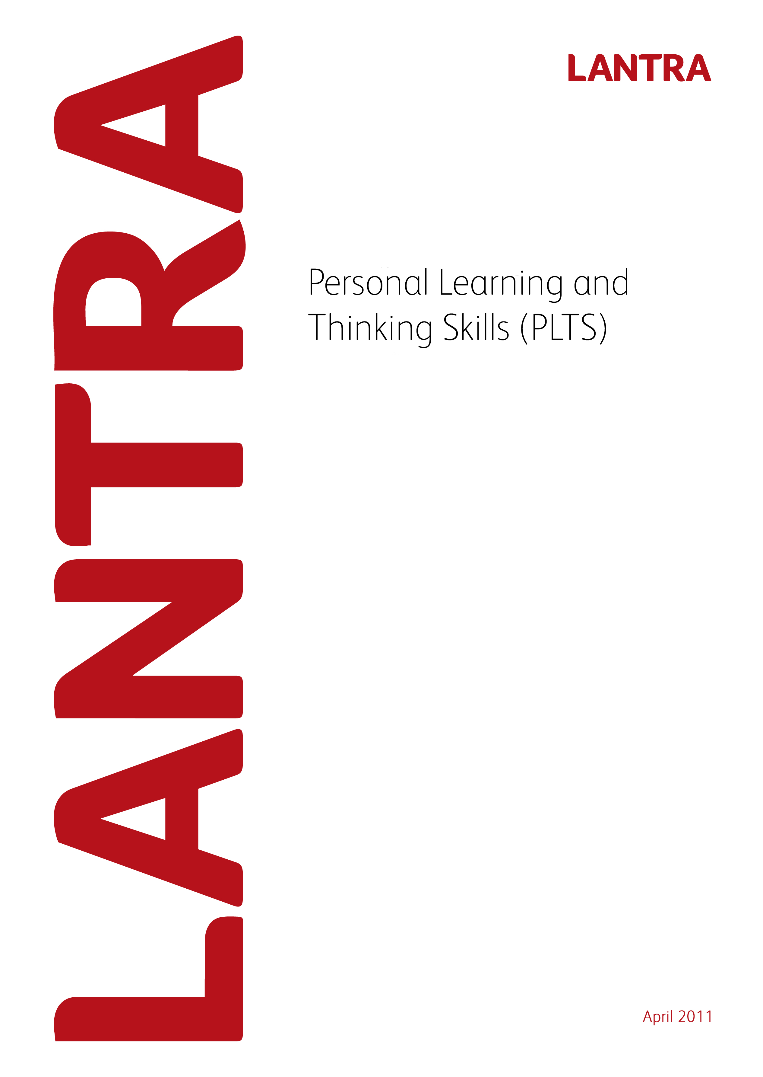

Record of Achievement for
Environmental Conservation
Level 2
Record of Achievement for
Horticulture
Level 3
February 2014

Personal Learning and Thinking Skills

Record of Achievement

Environmental Conservation Level 2

April 2011
This page has been intentionally left blank.

Record of Achievement
for
Personal Learning and Thinking Skills

Learner Name: _____________________________________________________

February 2014

Introduction

All apprenticeship frameworks must specify the outcomes which an apprentice is to achieve in the six Personal Learning and Thinking Skills (PLTS) listed below and how they are evidenced. Achievement of PLTS must be based on evidence that is subject to quality assurance. This Record of Achievement is based on quality assured evidence within the Level 3 Diploma in Work-based Horticulture qualification number 601/2522/6 offered by ABC Awards. The six PLTS and their outcomes include:

- Independent enquiry
- Creative thinking
- Reflective learning
- Team working
- Self management
- Effective participation

PLTS must be formally assessed. However; Lantra considers that assessment of units within the Work-based Diplomas provides relevant evidence for the achievement of PLTS. To this end, examples of where this evidence occurs and can be assessed, is provided within this document. Where there is an opportunity for a PLTS to be assessed, this appears as a blank (white) box. Assessors will need to list examples of evidence of how the PLTS have been achieved. Alternatively, assessor may devise their own sources of evidence and this needs to be specified, along with the unit within the Diploma where this alternative evidence occurred. Assessors will need to also sign and date at the end of each section.

Lantra does not require PLTS to be accredited. Although PLTS are referenced and mapped to QCF units within the Work-based Diplomas, assessors should be flexible in their interpretation to avoid discrimination against those with a learning difficulty. For example; care should be taken to ensure that interpretation of references to ‘speaking and listening’ are inclusive, as far as possible, of those with speech and hearing difficulties.

PLTS should be assessed alongside the learner’s assessment for the Work-based Diplomas and once achieved should be recorded on the following record sheets.

The sign off sheet at the end of the document should be completed by the learner and the assessor. The PLTS sign off sheet should be subject to the normal Internal Verifier sampling arrangements and so there is an opportunity for them to sign if appropriate. The sign off sheet should then be submitted to Lantra SSC when a claim is made for the Apprenticeship Certificate.

Independent enquirers | Creative thinkers | Reflective learners
- Identify questions to answer and problems to resolve  - Plan and carry out research, appreciating the consequences of decisions  - Explore issues, events or problems from different perspectives  - Analyse and evaluate information, judging its relevance and value  - Consider the influence of circumstances, beliefs and feelings on decision and events  - Support conclusions, using reasoned arguments and evidence | - Generate ideas and explore possibilities  - Ask questions to extend their thinking  - Connect their own and others’ ideas and experiences in inventive ways  - Question their own and others’ assumptions  - Try out alternatives or new solutions and follow ideas through  - Adapt ideas as circumstances change | - Assess themselves and others, identifying opportunities and achievements  - Set goals with success criteria for their development and review work  - Review progress, acting on the outcomes  - Invite feedback and deal positively with praise, setbacks and criticism  - Evaluate experiences and learning to inform future progress  - communicate their learning in relevant ways for different audiences
Team workers | Self-managers | Effective participators
- Collaborate with others to work towards common goals  - Reach agreements, managing discussions to achieve results  - Adapt behaviour to suit different roles and situations, including leadership roles  - Show fairness and consideration to others  - Take responsibility, showing confidence in themselves and their contribution  - Provide constructive support and feedback to others | - Seek out challenges or new responsibilities and show flexibility when priorities change  - Work towards goals, showing initiative, commitment and perseverance  - Organise time and resources, prioritising actions  - Anticipate, take and manage risks  - Deal with competing pressures, including personal and work-related demands  - Respond positively to change, seeking advice and support when needed  - Manage their emotions, and build and maintain relationships | - Discuss issues of concern, seeking resolution where needed  - Present a persuasive case for action  - Propose practical ways forward, breaking these down into manageable steps  - Identify improvements that would benefit others as well as themselves  - Try to influence others, negotiating the balancing diverse views to reach workable solutions  - Act as an advocate for views and beliefs that may differ from their own

Level 3 – Horticulture - Core Mandatory units for all pathways |  | Independent enquirers | Creative thinkers | Reflective learners | Team workers | Self-managers | Effective participators
Unit no. | Unit Title
D/502/1523 | Promote, monitor and maintain health, safety and security
Y/502/0502 | Estimate and programme resource requirements
F/501/2989 | Manage your own resources
Mandatory units – Production Horticulture
K/502/0956 | Provide nutrients to plants or crops
M/502/0957 | Monitor the development of crops or plants
R/502/1471 | Plan and manage the control of pests, diseases and disorders
Mandatory units – Landscaping
J/502/1225 | Specify the maintenance of landscapes
K/502/1282 | Monitor landscape maintenance and inspect landscape features and facilities
Mandatory units – Sports Turf (Groundsman & Greenkeeper)
L/502/0500 | Evaluate ground and environmental conditions to establish grassed and planted areas
D/502/0503 | Prepare sites for soft landscape establishment
H/502/0857 | Establish grass swards
H/502/0504 | Plan the maintenance, repair and renovation of sports turf areas
R/502/0501 | Plan and set out sports areas
F/502/1272 | Maintain irrigation systems
A/501/2998 | Manage information for action
Mandatory units – Parks, Gardens and Green Space
R/502/1471 | Plan and manage the control of pests, diseases and disorders

Evidence of completing the six PLTs and their outcomes

Independent Enquiry

Reasons/examples of how learners may achieve the marked PLTS

Example: Carry out unit ‘Plan and set out sports areas’ the candidate will have identified any problems which need resolving, survey the area which requires setting out, completing outcomes 1, 2, 3, and 4.

Creative Thinking

Reasons/examples of how learners may achieve the marked PLTS

Example: Carry out unit ‘Monitor the development of crops and plants’ the candidate will have explored the crop development, extended their think by asking questions, completing outcomes 1 and 2.

Reflective Learning

Reasons/examples of how learners may achieve the marked PLTS

Example: Carry out unit ‘Promote, monitor and maintain health, safety and security’ the candidate will have assessed themselves, reviewed progress, invite feedback and evaluate their experiences (e.g.), completing outcomes 1, 3, 4 and 5.

Team Working

Reasons/examples of how learners may achieve the marked PLTS

Example: Carry out unit ‘Plan and manage the control of pests, diseases and disorders’ the candidate will have worked with others to achieve common gaols, adapted their behaviour to suit different roles and situations, considered others opinions and supporting colleagues, completing outcomes 1, 3, 4 and 6.

Self Management

Reasons/examples of how learners may achieve the marked PLTS

Example: Carry out unit ‘Plan and manage the control of pests, diseases and disorders’ the candidate will have shown flexibility when priorities change, organised their time and resources according to planting schedule, dealt with competing pressures, responded positively to change, sort advice and support when needed, completing outcomes 1, 3, 5, and 6.

Effective Participation

Reasons/examples of how learners may achieve the marked PLTS

Example: Carry out unit ‘Specify the maintenance of landscapes’ the candidate will have shown they can discuss issues of concern and seek resolutions where needed when problems occur with planting, present cases to improve working schedules, identify ways to improve the work plan, completing outcomes 1, 3, 4 and 5.

Record of Achievement
for
Personal Learning and Thinking Skills

Learner Name: __________________________________

Sign off sheet

I confirm that the learner has completed PLTS for the Level 2 Diploma in Work-based Horticulture as part of an Apprenticeship Framework (please complete in BLOCK CAPITALS).

Learner Name: …………………………………. Signature: ………………

Date:………………

Assessor Name: …………………………………. Signature: ………………

Date: ………………

Internal Verifier Name: …………………………………. Signature: ………………

Date: ………………

Please file this paperwork for proof of completing PLTS.

This page has been intentionally left blank.

