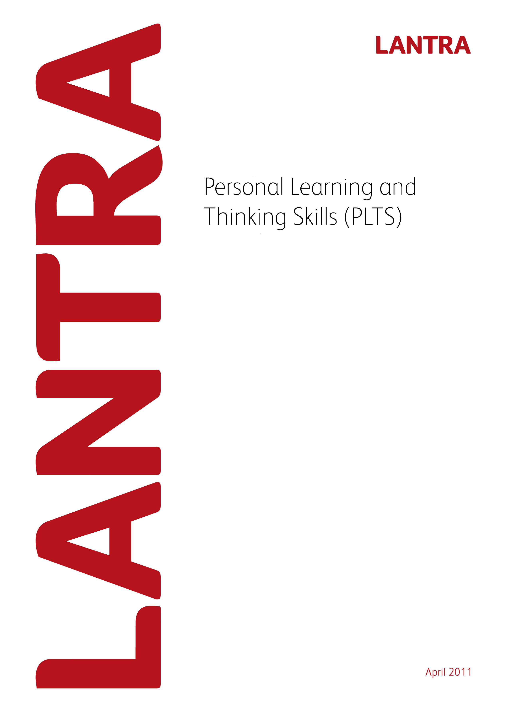
Record of Achievement for
Trees and Timber
Level 2

March 2013
This page has been intentionally left blank
Record of Achievement
for
Personal Learning and Thinking Skills

Learner Name: ____________________________________________________

March 2013

Introduction

All apprenticeship frameworks must specify the outcomes which an apprentice is to achieve in the six Personal Learning and Thinking Skills (PLTS) listed below and how they are evidenced. Achievement of PLTS must be based on evidence that is subject to quality assurance. This Record of Achievement is based on quality assured evidence within the Level 2 Diploma in Work-based Trees and Timber. The six PLTS and their outcomes include:

- Independent enquiry
- Creative thinking
- Reflective learning
- Team working
- Self management
- Effective participation

PLTS must be formally assessed. However, Lantra considers that assessment of units within the Work-based Diploma provides relevant evidence for the achievement of PLTS. To this end, examples of where this evidence occurs and can be assessed, is provided within this document. Where there is an opportunity for PLTS to be assessed, this appears as a blank (white) box. Assessors will need to list examples of evidence to show how the PLTS have been achieved. Alternatively, assessors may devise their own sources of evidence and this needs to be specified, along with the unit within the Work-based Diploma where this alternative evidence occurred.

Lantra does not require PLTS to be accredited. Although PLTS are referenced and mapped to QCF units within the Work-based Diplomas, assessors should be flexible in their interpretation to avoid discrimination against those with a learning difficulty. For example care should be taken to ensure that interpretation of references to ‘speaking and listening’ are inclusive, as far as possible, of those with speech and hearing difficulties.

PLTS should be assessed alongside the learner’s assessment for the Work-based Diplomas and once achieved should be recorded on the evidence sheets.

The sign off sheet at the end of the document should be completed by the learner and the assessor. The PLTS sign off sheet should be subject to the normal Internal Verifier sampling arrangements and so there is an opportunity for them to sign if appropriate. A copy of the sign off sheet should then be uploaded to ACE when a claim is made for the Apprenticeship Certificate.
This page has been intentionally left blank
PLTs Outcomes

Independent enquirers | Creative thinkers | Reflective learners
- Identify questions to answer and problems to resolve  - Plan and carry out research, appreciating the consequences of decisions  - Explore issues, events or problems from different perspectives  - Analyse and evaluate information, judging its relevance and value  - Consider the influence of circumstances, beliefs and feelings on decision and events  - Support conclusions, using reasoned arguments and evidence | - Generate ideas and explore possibilities  - Ask questions to extend their thinking  - Connect their own and others’ ideas and experiences in inventive ways  - Question their own and others’ assumptions  - Try out alternatives or new solutions and follow ideas through  - Adapt ideas as circumstances change | - Assess themselves and others, identifying opportunities and achievements  - Set goals with success criteria for their development and review work  - Review progress, acting on the outcomes  - Invite feedback and deal positively with praise, setbacks and criticism  - Evaluate experiences and learning to inform future progress  - Communicate their learning in relevant ways for different audiences
Team workers | Self-managers | Effective participators
- Collaborate with others to work towards common goals  - Reach agreements, managing discussions to achieve results  - Adapt behaviour to suit different roles and situations, including leadership roles  - Show fairness and consideration to others  - Take responsibility, showing confidence in themselves and their contribution  - Provide constructive support and feedback to others | - seek out challenges or new responsibilities and show flexibility when priorities change  - Work towards goals, showing initiative, commitment and perseverance  - Organise time and resources, prioritising actions  - Anticipate, take and manage risks  - Deal with competing pressures, including personal and work-related demands  - Respond positively to change, seeking advice and support when needed  - Manage their emotions, and build and maintain relationships | - Discuss issues of concern, seeking resolution where needed  - Present a persuasive case for action  - Propose practical ways forward, breaking these down into manageable steps  - Identify improvements that would benefit others as well as themselves  - Try to influence others, negotiating the balancing diverse views to reach workable solutions  - Act as an advocate for views and beliefs that may differ from their own
PLTs mapped to units within the Level 2 Work-based Diploma in Trees and Timber

Where there is an opportunity for PLTs to be assessed, this appears as a blank (white) box.

 |  | Independent enquirers | Creative thinkers | Reflective learners | Team workers | Self-managers | Effective participators
Level 2 – Work-based Diploma in Trees and Timber (Arboriculture)
Unit no. | Unit Title
L/504/3694 | Identify tree species and their properties
M/504/3641 | Control pollution incidents
Y/501/6353 | Monitoring and maintaining health and safety
F/504/3658 | Process arisings from tree work operations
K/504/0320 | Carry out maintenance of chainsaw and cutting system
M/504/0321 | Fell and process trees up to 380 mm
T/504/0319 | Cross-cut timber using a chainsaw
F/504/0596 | Support colleagues undertaking off ground tree relation operations
Level 2 Work-based Diploma in Trees and Timber (General Woodland and Forestry Treework)
Unit no. | Unit Title
L/504/3694 | Identify tree species and their properties
M/504/3641 | Control pollution incidents
Y/501/6353 | Monitoring and maintaining health and safety
K/502/1511 | Identify and report the presence of pests, diseases and disorders
Level 2 Work-based Diploma in Trees and Timber (Coppicing and Green Wood Trades)
L/504/3694 | Identify tree species and their properties
M/504/3641 | Control pollution incidents
Y/501/6353 | Monitoring and maintaining health and safety
M/504/0321 | Fell and process trees up to 380 mm
T/504/0319 | Cross-cut timber using a chainsaw
K/504/3671 | Cut, process and extract coppice
H/504/3670 | Sharpen and maintain edged hand tools
H/504/3667 | Process coppice materials and greenwood products

Evidence of completing the six PLTs and their outcomes

Independent Enquiry

Reasons/examples of how learners may achieve the marked PLTS

Example: Carrying out unit ‘Identify tree species and their properties’ the candidate will have undertook research (e.g.), analysed results (e.g.) and supported conclusions (e.g.), completing outcomes 1, 2, 4 and 6.

Creative Thinking

Reasons/examples of how learners may achieve the marked PLTS

Example: Carrying out unit ‘Control pollution incidents’ the candidate will have asked questions, tried out alternative or new solutions and adapted ideas (e.g.), completing outcomes 2, 5, and 6.

Reflective Learning

Reasons/examples of how learners may achieve the marked PLTS

Example: Carry out unit ‘Monitoring and maintaining health and safety’ the candidate will have assessed themselves, reviewed progress, invite feedback and evaluate their experiences (e.g.), completing outcomes 1, 3, 4 and 5.

Team Working

Reasons/examples of how learners may achieve the marked PLTS

Example: Carry out unit ‘Control pollution incidents’ the candidate will have collaborated with others when working on (e.g.) and provide constructive support and feedback to others (e.g.), completing outcomes 1 and 6.

Self Management

Reasons/examples of how learners may achieve the marked PLTS

Example: Carry out unit ‘Control pollution incidents’ the candidate will organise their time, deal with competing pressures, respond to change and build and maintain relationships (e.g.), completing outcomes 3, 5, 6 and 7.

Effective Participation

Reasons/examples of how learners may achieve the marked PLTS

Example: Carry out unit ‘Identify tree species and their properties’ the candidate will discuss issues and seek resolutions, propose practical ways forward and identify improvements (e.g.), completing outcomes 1, 3 and 4.

Record of Achievement
for
Personal Learning and Thinking Skills

Learner Name: __________________________________

Sign off sheet

I confirm that the learner has completed PLTS for the Level 2 Diploma in Work-based Trees and Timber as part of an Apprenticeship Framework (please complete in BLOCK CAPITALS).

Learner Name: …………………………………. Signature: ………………

Date:………………

Assessor Name: …………………………………. Signature: ………………

Date: ………………

Internal Verifier Name: …………………………………. Signature: ………………

Date: ………………

Please submit this sheet to ACE on completion of the Apprenticeship Framework.

