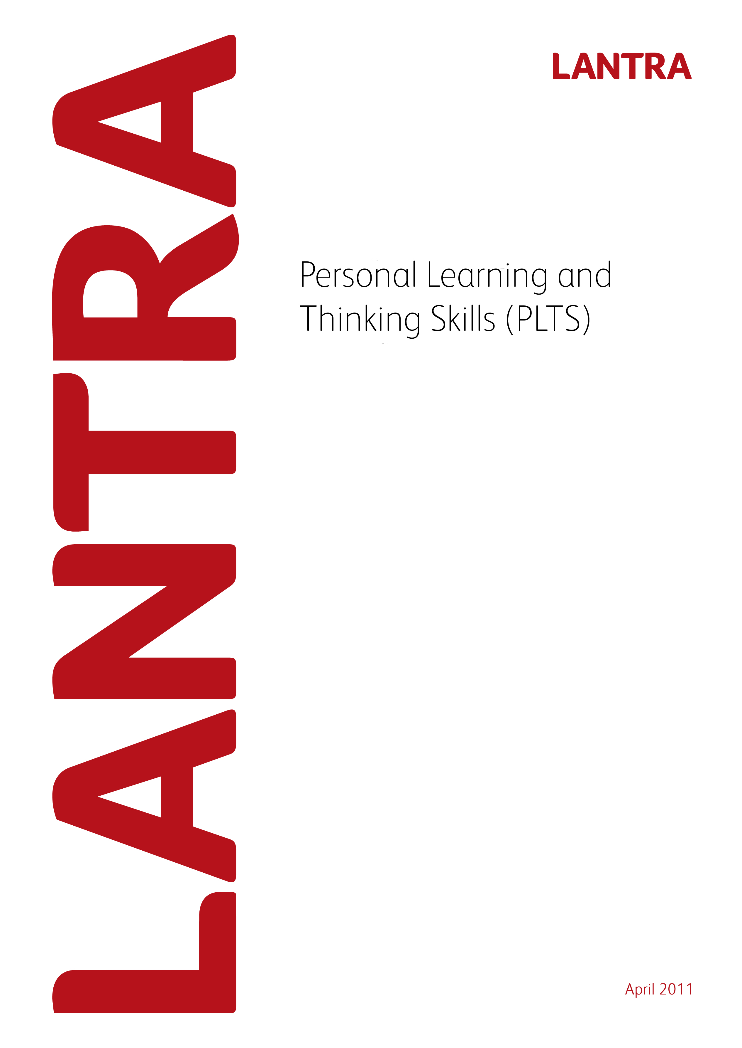
Record of Achievement for
Dry Stone Walling
Level 3
Record of Achievement for
Dry Stone Walling
Level 3
July 2011

Record of Achievement
for
Personal Learning and Thinking Skills

Learner Name: ____________________________________________

July 2011 Version 1

Introduction

All apprenticeship frameworks must specify the outcomes which an apprentice is to achieve in the six Personal Learning and Thinking Skills (PLTS) listed below and how they are evidenced. Achievement of PLTS must be based on evidence that is subject to quality assurance. This Record of Achievement is based on quality assured evidence within the Level 3 Certificate in Dry Stone Walling. The six PLTS and their outcomes include:

- Independent enquiry
- Creative thinking
- Reflective learning
- Team working
- Self management
- Effective participation

PLTS must be formally assessed. However; Lantra considers that assessment of units within the Work-based Diplomas provides relevant evidence for the achievement of PLTS. To this end, examples of where this evidence occurs and can be assessed, is provided within this document. Where there is an opportunity for a PLTS to be assessed, this appears as a blank (white) box. Assessors will need to list examples of evidence of how the PLTS have been achieved. Alternatively, assessor may devise their own sources of evidence and this needs to be specified, along with the unit within the Diploma where this alternative evidence occurred. Assessors will need to also sign and date at the end of each section.

Lantra does not require PLTS to be accredited. Although PLTS are referenced and mapped to QCF units within the Work-based Diplomas, assessors should be flexible in their interpretation to avoid discrimination against those with a learning difficulty. For example; care should be taken to ensure that interpretation of references to ‘speaking and listening’ are inclusive, as far as possible, of those with speech and hearing difficulties.

PLTS should be assessed alongside the learner’s assessment for the Work-based Diplomas and once achieved should be recorded on the following record sheets.

The sign off sheet at the end of the document should be completed by the learner and the assessor. The PLTS sign off sheet should be subject to the normal Internal Verifier sampling arrangements and so there is an opportunity for them to sign if appropriate. The sign off sheet should then be submitted to Lantra SSC when a claim is made for the Apprenticeship Certificate.

Independent enquirers | Creative thinkers | Reflective learners
1 identify questions to answer and problems to resolve  2 plan and carry out research, appreciating the consequences of decisions  3 explore issues, events or problems from different perspectives  4 analyse and evaluate information, judging its relevance and value  5 consider the influence of circumstances, beliefs and feelings on decision and events  6 support conclusions, using reasoned arguments and evidence | 1 generate ideas and explore possibilities  2 ask questions to extend their thinking  3 connect their own and others’ ideas and experiences in inventive ways  4 question their own and others’ assumptions  5 try out alternatives or new solutions and follow ideas through  6 adapt ideas as circumstances change | 1 assess themselves and others, identifying opportunities and achievements  2 set goals with success criteria for their development and review work  3 review progress, acting on the outcomes  4 invite feedback and deal positively with praise, setbacks and criticism  5 evaluate experiences and learning to inform future progress  6 communicate their learning in relevant ways for different audiences
Team workers | Self-managers | Effective participators
1 collaborate with others to work towards common goals  2 reach agreements, managing discussions to achieve results  3 adapt behaviour to suit different roles and situations, including leadership roles  4 show fairness and consideration to others  5 take responsibility, showing confidence in themselves and their contribution  6 provide constructive support and feedback to others | 1 seek out challenges or new responsibilities and show flexibility when priorities change  2 work towards goals, showing initiative, commitment and perseverance  3 organise time and resources, prioritising actions  4 anticipate, take and manage risks  5 deal with competing pressures, including personal and work-related demands  6 respond positively to change, seeking advice and support when needed  7 manage their emotions, and build and maintain relationships | 1 discuss issues of concern, seeking resolution where needed  2 present a persuasive case for action  3 propose practical ways forward, breaking these down into manageable steps  4 identify improvements that would benefit others as well as themselves  5 try to influence others, negotiating the balancing diverse views to reach workable solutions  6 act as an advocate for views and beliefs that may differ from their own

Dry Stone Walling Mandatory units |  | Independent enquirers | Creative thinkers | Reflective learners | Team workers | Self-managers | Effective participators
Level 3 – Dry Stone Walling
Unit no. | Unit Title
M/600/2162 | Prepare to Build a Dry Stone Wall
L/600/2167 | Building a Checkend to a Dry Stone Wall
A/600/2407 | Building a Retaining Dry Stone Wall
J/600/2409 | Building a Curved Dry Stone Wall
D/600/2416 | Building a Dry Stone Wall on Sloping Ground
R/600/2414 | Building a High Dry Stone Wall
A/600/2410 | Incorporating a Lunkie Hole into a Dry Stone Wall
 | Employee Rights and Responsibilities Workbook

Reasons/examples of how learners may achieve the marked PLTS
The examples above are provided as guidance and learners and their tutor or employer may identify other areas where these Skills can be achieved.

Team working and effective participation skills may be developed where learners are working in areas they may have to take account of local needs and provide feedback to others. As part of their role the learners should be working to implement good environmental practice at work and taking account of the land and vegetation around them.

Learners who have not completed the employee rights and responsibilities workbook for the Intermediate Apprenticeship will be able to use this to provide evidence for the independent enquirers, creative thinkers and reflective learners through research into the dry stone walling and wider environmental and land-based industry.

I confirm that this candidate has achieved the PLTS for this framework.

Assessor name: __________________________

Assessor signature: __________________________

Date: __________________________

Record of Achievement
for
Personal Learning and Thinking Skills

Learner Name: ___________________________________________________

Sign off sheet

I confirm that the learner has completed PLTS for the Level 3 Certificate in Dry Stone Walling as part of an Apprenticeship Framework (please complete in BLOCK CAPITALS).

Learner Name: …………………………………. Signature: ………………

Date:………………

Assessor Name: …………………………………. Signature: ………………

Date: ………………

Internal Verifier Name: …………………………………. Signature: ………………

Date: ………………

Please return this sheet to Lantra SSC on completion of the Apprenticeship Framework.

This page has been intentionally left blank.

